**What are the consequences of Israel’s annexation of East Jerusalem for Palestinians?**

**Lesson 17**

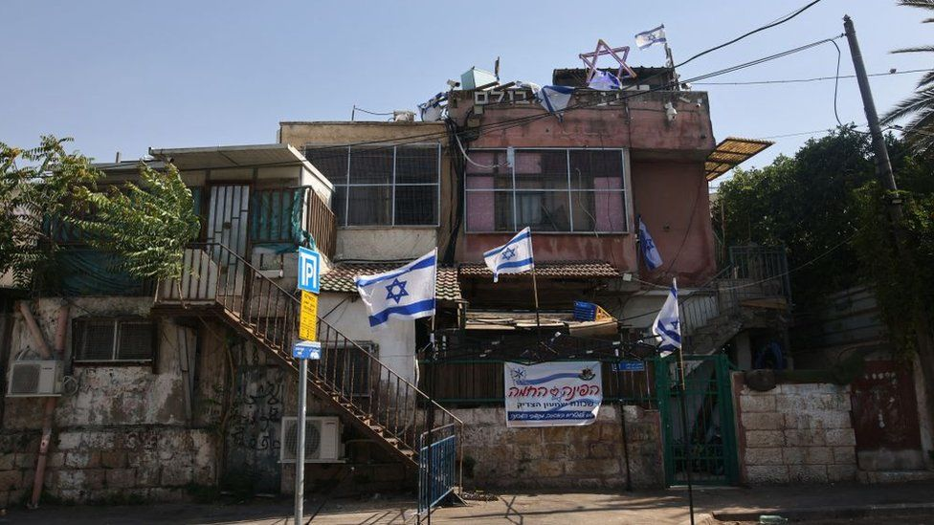

**By the end of this lesson, you should be able to:**

Describe Israel’s annexation of East Jerusalem

Describe what the Separation Wall is

Explain the consequences of both of these for Palestinians

**Keywords**

Annexation

East Jerusalem

Eviction

Separation Wall

**Israel’s annexation of East Jerusalem**

After occupying East Jerusalem in 1967, Israel **annexed** East Jerusalem in 1980. Annexation is the forcible acquisition (taking control) of land

This was **illegal under international law** because after 1967, East Jerusalem was occupied territory and under international law, you cannot make occupied territory your own.

Thus Israel’s annexation of East Jerusalem was condemned by **UN Security Council Resolution 478** in 1980

**Questions**

What had happened in 1967?

Was Israel’s annexation of East Jerusalem in 1980 legal? Why/why not?

What is the difference between occupation and annexation?

**Jerusalem – the divided city**

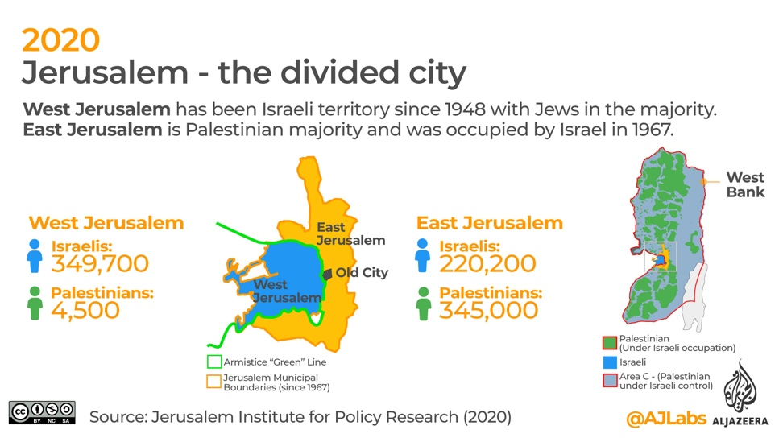

What are some of the differences between East and West Jerusalem?

**What are the consequences of Israel’s annexation of East Jerusalem for Palestinians?**

There are two main consequences:

1.Evictions and home demolitions

2.Restricted movement

**Evictions and home demolitions**

Eviction: when someone is forced to leave a house or piece of land

Home demolition: the destruction of a home

In East Jerusalem, Palestinians face evictions and home demolitions to make way for illegal Israeli settlements. **Since 1967, Israel has demolished 1000 Palestinian homes in East Jerusalem.** Since 1948, Israel has demolished over 100,000 Palestinian homes

**#SaveSheikhJarrah**

Sheikh Jarrah is a neighbourhood in East Jerusalem. In May 2021, Palestinian families in Sheikh Jarrah faced evictions from their homes to make way for illegal Israeli settlers. **#SaveSheikhJarrah** started trending on social media. It soon made international headlines

The events in Sheikh Jarrah led to the **2021 Israel-Palestine Crisis**. Between 6th May and 21st May 2021, over 250 Palestinians were killed, half of them civilians. In Gaza, Israel bombed civilians and has been accused of war crimes

This shows that what happens in East Jerusalem matters. It impacts all of Palestine and Israel

**Israeli war crimes**

A war crime is the **breaking of one of the laws of war**. The laws of war were introduced after the atrocities of World War Two (eg. the Holocaust)

War crimes include the deliberate and unprovoked destruction of communities, **devastation beyond military necessity** and the **ill-treatment, torture or murder of civilians living under occupation**

War crimes are among the gravest crimes in international law. They are so serious that there is no time limit for when someone can be punished for committing them

**Questions**

Why has Israel been accused of war crimes for its attacks on Gaza in May 2021?

Have you come across any other examples of war crimes in Palestine-Israel?

**Question**

How would you feel if you were Palestinian and lived in East Jerusalem?

**Restricted movement**

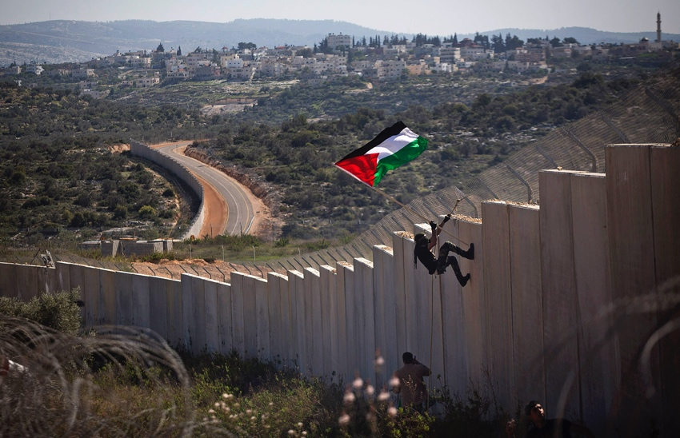

During the Second Intifada (2000-2005), Israel built a **Separation Wall** along its border with the occupied West Bank. Israel started building the wall for security reasons, but has since been criticised for using the wall to take more Palestinian land

The Separation Wall is 6-8 metres high and when finally completed it will be over 700km in length

The Wall **severely impacts the freedom of movement of Palestinians**

**The Separation Wall**

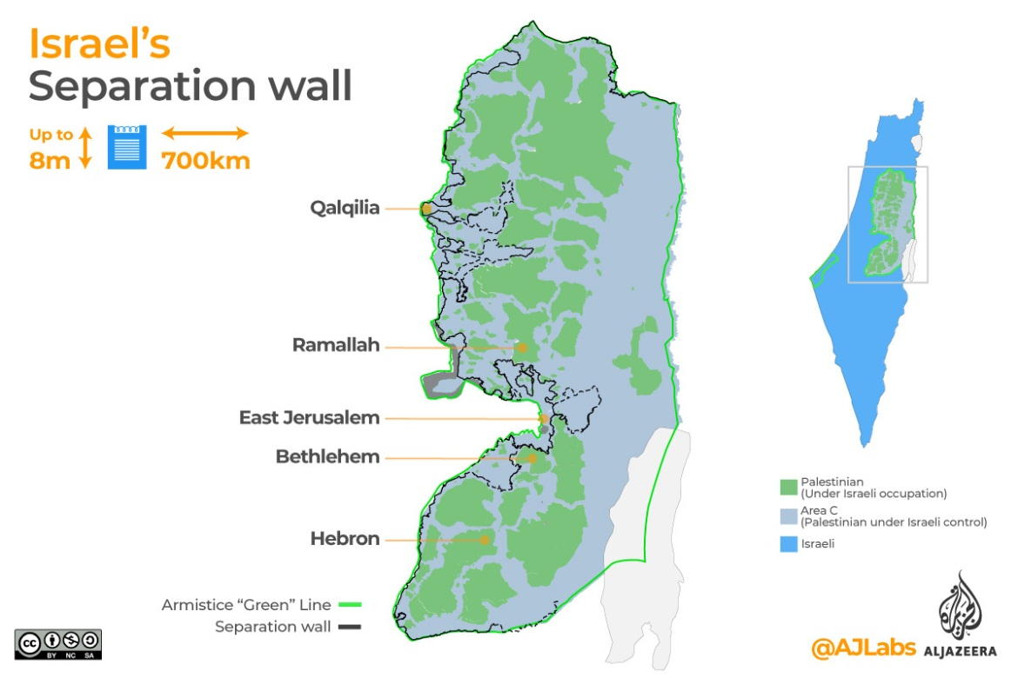

**The consequences of the Separation Wall**

The Wall has **severely damaged** Palestinian agriculture, towns and villages. **225** water sources have been taken from the Palestinians by the route of the Wall. The Wall is meant to run along the Green Line of 1949, but at times it penetrates up to **16km** into Palestinian land. This means that around **300,000** Palestinians have been cut off from their communities by the Wall. They are trapped between the Wall and the Green Line

**The Wall in East Jerusalem**

The Wall runs around Israeli settlements and **cuts East Jerusalem off from the rest of the occupied West Bank**. This means it is almost impossible for Palestinians in East Jerusalem to travel to other parts of occupied Palestine to see family and friends

The Separation Wallhas many different names: Israelis call it the Security Wall but Palestinians call it the Separation Wall, Apartheid Wall or Racial Segregation Wall

**The Wall and international law**

In 2004, the International Court of Justice stated that the Apartheid Wall was ‘contrary to international law’ and called on Israel to ‘cease forthwith the works of construction of the Wall’ and ‘dismantle forthwith the structure therein situated’

**Questions**

What is the Separation Wall?

What impact does the Separation Wall have on the freedom of movement of Palestinians in East Jerusalem?

**Born unequal**

**Questions**

1.How is life different for illegal Israeli settlers and Palestinians in East Jerusalem?

2.Is this fair?

3.How does this make you feel?